**Reports parameters for table and charts**

**Json link for all these parameters:-**

[**https://api.myjson.com/bins/4g2qr**](https://api.myjson.com/bins/4g2qr)

I have added all the json parameters, if u find any data missing, u can edit here in this link <http://myjson.com/> (you can paste my json, add the necessary data and save it, this will give a separate link and you can use that)

Pls note:- This is the actual json feed from the Django server, so a little changes to the following fields..

**Id** need to change it to **pk**

**Site** to **sites**

**Zone** to**zones (rest all are same)**

**\*\*\*\*\*\*\*\*\*\*\*\*\*\*\*\*\*\*\*\*\*\*\*\*\*\*\*\*\*\*\*\*\*\*\*\*\*\*\*\*\*\*\*\*\*\*\*\*\*\*\*\*\*\*\*\*\*\*\*\*\*\*\*\*\*\*\*\*\*\*\*\*\*\*\*\*\*\*\*\*\*\*\*\*\*\*\*\*\***

As Discussed, I have made all the parameters for most of the tables I have and have put it up along with their pictures for reference. Kindly have a look.

Most of the reports, I do not have a mock-up, so I have commented what has to be done for those. I will edit them as and when I get the mock-ups.

****************************************************************************************

**Pls note:- This date menu, we have some different options in these mock-ups, I just noticed..**

**foreg:- some reports have Year selection, weekly selection, Date wise selection and Monthly selection. We need to be smart here and find a solution for this. What I mean is, Instead of having 4 different options for dates, can we combine them into one and make it as one drop-down???**

**This is a tricky part, not sure how to do this, we need to find a solution so that we don’t end up making too many drop-down selections**

**\*\*\*\*\*\*\*\*\*\*\*\*\*\*\*\*\*\*\*\*\*\*\*\*\*\*\*\*\*\*\*\*\*\*\*\*\*\*\*\*\*\*\*\*\*\*\*\*\*\*\*\*\*\*\*\*\*\*\*\*\*\*\*\*\*\*\*\*\*\*\*\*\*\*\*\*\*\*\*\*\*\*\*\*\***

**Below is the list in which these reports are created:-**

* **Hourly Retail Reports**

**a) HourlyRetailComparisionReport**

**b) DailyRetailExecutiveSummaryReport**

**c) DailyRetailTrendAnalysisReport**

* **Hourly Traffic Reports**

**a) HourlyTrafficCalendarSummaryReport**

**b) HourlyTrafficComparisonReport**

**c) HourlyTrafficTrendAnalysisReport**

* **Daily Retail Reports**

**a) DailyRetailComparisionReport**

**b) DailyRetailExecutiveSummaryReport**

**c) DailyRetailTrendAnalysisReport**

* **Daily Traffic Reports**

**a) DailyTrafficCalendarSummaryReport**

**b) DailyTrafficComparisonReport**

**c) DailyTrafficTrendAnalysisReport**

* **Weekly Retail Reports**

**a) WeeklyRetailComparisionReport**

**b) WeeklyRetailExecutiveSummaryReport**

**c)  WeeklyRetailTrendAnalysisReport**

* **Weekly Traffic Reports**

**a) WeeklyTrafficCalendarSummaryReport**

**b) WeeklyTrafficComparisonReport**

**c) WeeklyTrafficTrendAnalysisReport**

* **Monthly Retail Reports**

**a) MonthlyRetailComparisionReport**

**b) MonthlyRetailExecutiveSummaryReport**

**c)  MonthlyRetailTrendAnalysisReport**

* **Monthly Traffic Reports**

**a) MonthlyTrafficCalendarSummaryReport**

**b) MonthlyTrafficComparisonReport**

**c) MonthlyTrafficTrendAnalysisReport**

* **Yearly Retail Reports**

**a) YearlyRetailComparisionReport**

**b) YearlyRetailExecutiveSummaryReport**

**c)  YearlyRetailTrendAnalysisReport**

* **Yearly Traffic Reports**

**a) YearlyTrafficCalendarSummaryReport**

**b) YearlyTrafficComparisonReport**

**c) YearlyTrafficTrendAnalysisReport**

**Other Client Reports**

1. **WeeklyDayWisePerformanceReport**
2. **Keyhour Report**
3. **Weekly hourly Report**
4. **Weekly Comparison Report(different from the one above)**
5. **Hourly Comparison Sites (different from the one above)**
6. **Monthly Performance Report (different from the one above)**
7. **Monthly KeyHour Report (different from the one above)**

* **Hourly Retail Reports**
  1. **HourlyRetailComparisionReport**

**Details required in the table:-**

1. TIME PERIOD
2. VISITORS

**Details required in high charts:-**

1. Visitors (column chart)

Pls note:- There is a maroon div where it shows the total of visitors, this value will change based on the drop-down selection

Eg:- This is how this report looks (but the chart should go down) no need of the above spline chart(only column)**(pls zoom the picture to see it more clearly)**

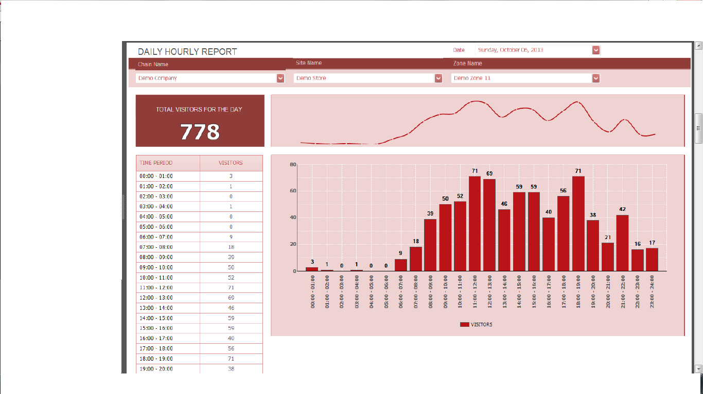

1. **HourlyRetailExecutiveSummaryReport**

No table and High chart required… like I showed you it’s like the table values, all the values inside will change based in the drop down selected or even based on the multiple drop-down selected

**(pls zoom the picture to see it more clearly)**

Eg:-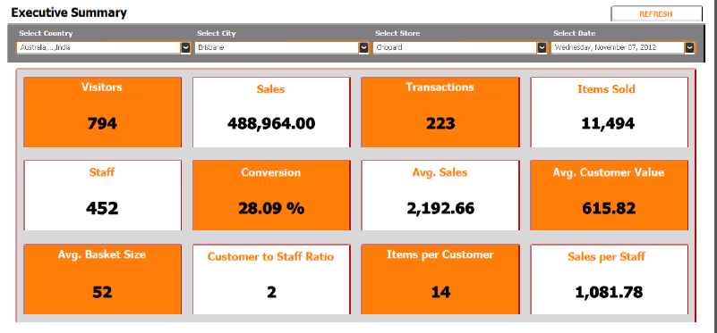

1. **HourlyRetailTrendAnalysisReport**

No table and High chart required… like I showed u it’s like the table values, all the values inside will change based in the drop down selected or even based on the multiple drop-down selected

**(pls zoom the picture to see it more clearly)**

Eg:-

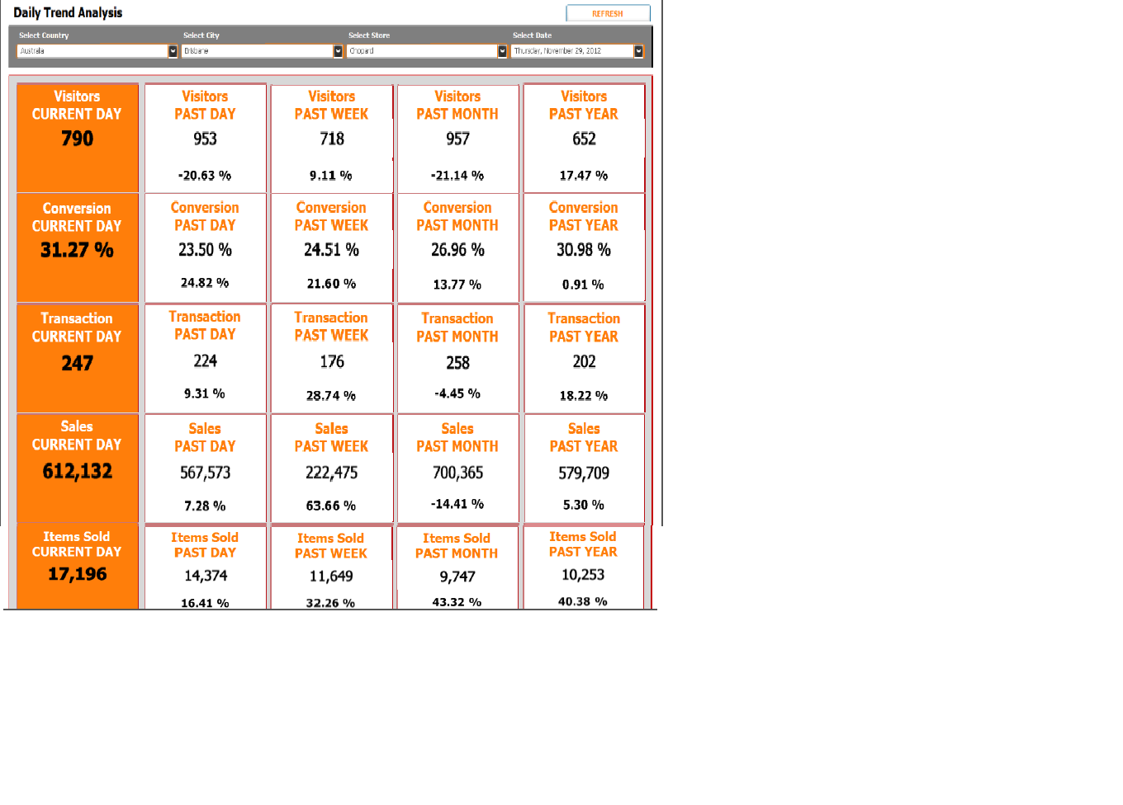

* **Hourly Traffic Reports**
  1. **HourlyTrafficCalendarSummaryReport**

Calendar Report I will get back to you

* 1. **HourlyTrafficComparisonReport**

**Details required in the table:-**

1. TIME PERIOD
2. VISITORS
3. VISITORS(PREVIOUS DAY)
4. % CHANGE (PREVIOUS DAY)
5. VISITORS (PAST WEEK)
6. % CHANGE (PAST WEEK)

**Details required in high charts:-**

1. Time Period (to show values in column)

Eg:- This is how this report looks (but the chart should go down)

**(pls zoom the picture to see it more clearly)**

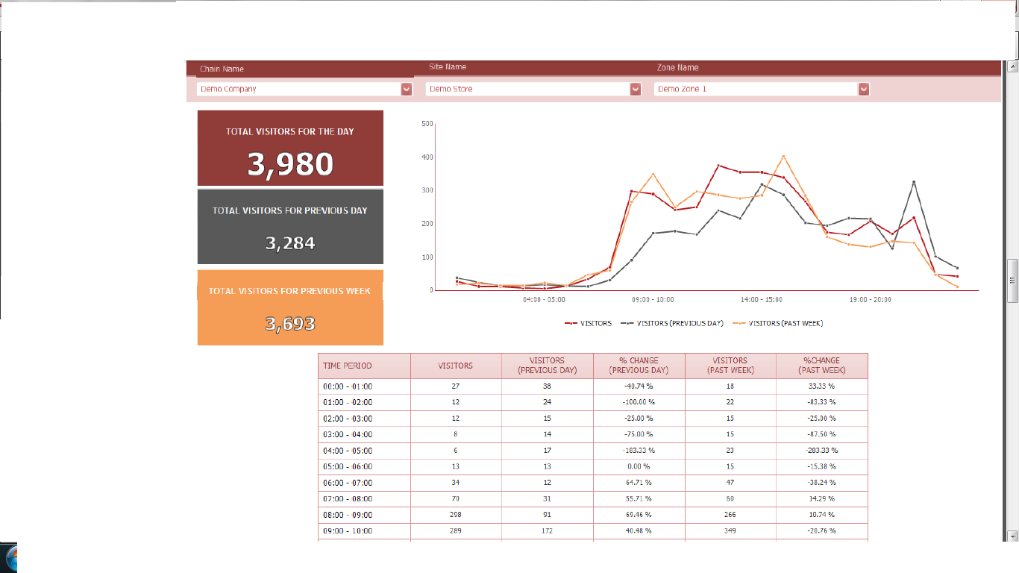

* 1. **HourlyTrafficTrendAnalysisReport**

Haven’t decided on this report yet

* **Daily Retail Reports**
  1. **DailyRetailComparisionReport**

Keep it the same as Hourly comparison report, just name the report as

**DailyRetailComparisonReport** (I will change the values later)

* 1. **DailyRetailExecutiveSummaryReport**

Keep it the same as Hourly Retail Executive Summary comparison report, just name the report as **DailyRetailExecutiveSummaryReport** (I will change the values later)

* 1. **DailyRetailTrendAnalysisReport**

Keep it the same as Hourly Retail Trend Analysis report, just name the report as **DailyRetailTrendAnalysisReport** (I will change the values later)

* **Daily Traffic Reports**
  1. **DailyTrafficCalendarSummaryReport**

Calendar Report I will get back to you

* 1. **DailyTrafficComparisonReport**

Keep it the same as Hourly Traffic Comparison report, just name the report as **DailyTrafficComparisonReport** (I will change the values later)

* 1. **DailyTrafficTrendAnalysisReport**

**Details required in the table:-**

1. TIME PERIOD
2. VISITORS
3. SALES
4. TRANS
5. ITEMS
6. STAFF
7. %CONV
8. AVG SALES
9. AVG CUST VALUE
10. AVG BASKET SIZE
11. STAR
12. ITEMS PER CUST
13. SALES PER SATFF

**Details required in high charts:-**

a) Time Period (to show values in column)

b) %CONV graph to be shown as spline (pls refer image)

Eg:- This is how this report looks **(pls zoom the picture to see it more clearly)**

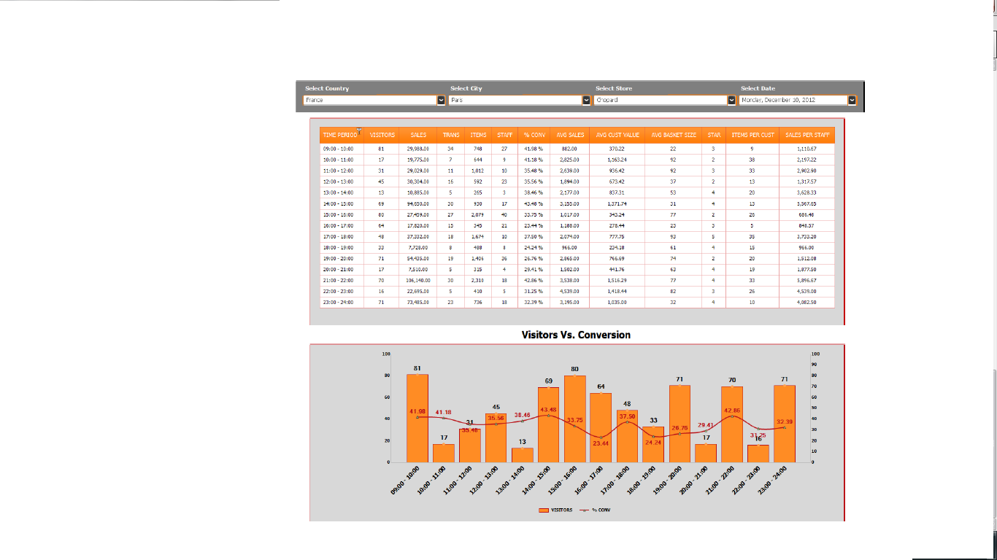

* **Weekly Retail Reports**
  1. **WeeklyRetailComparisionReport**

**Details required in the table:-**

1. MALL ENTRANCES

(this report shows date values based on the date selected(MULTI-SELECT), as shown in this image, can this be done??)

**Details required in high charts:-**

Mall entrances (no highchart here, but lets have onehighchart for this with mall entrances)**(pls zoom the picture to see it more clearly)**

­­­­­­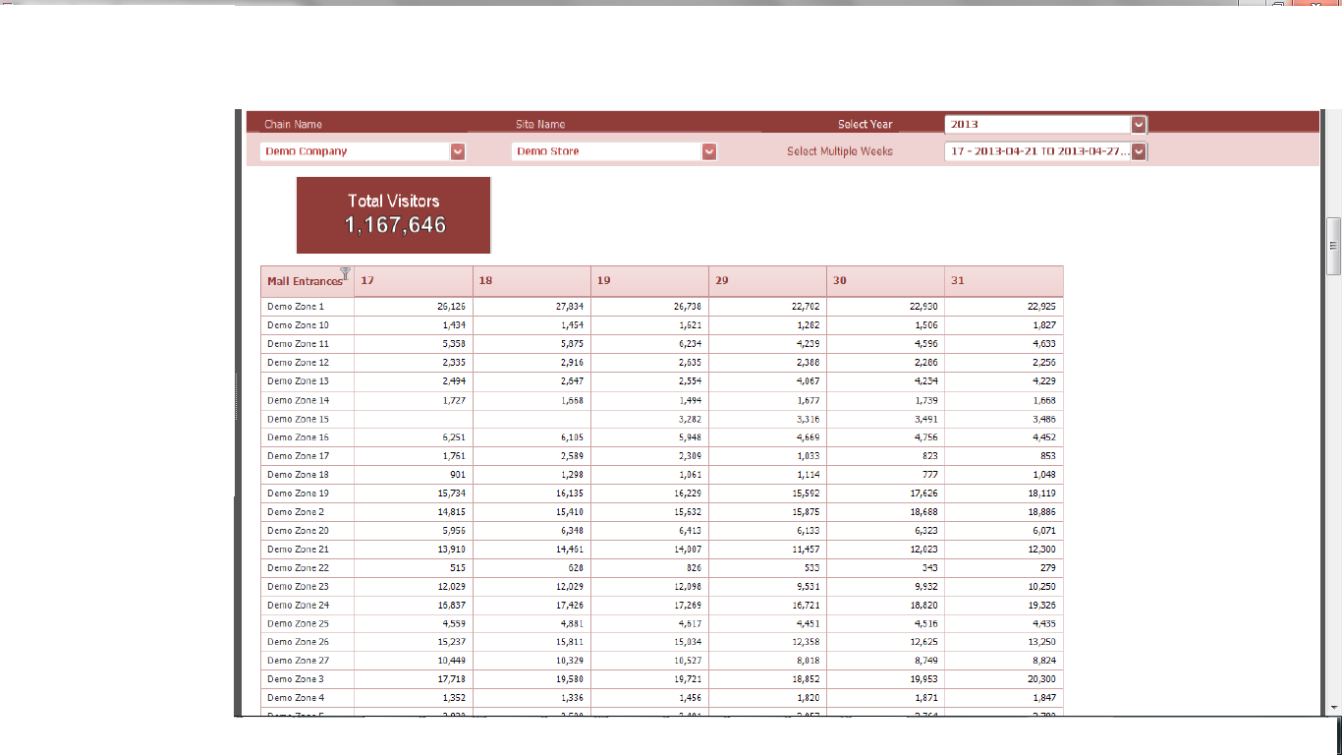

1. **WeeklyRetailExecutiveSummaryReport**

Keep it the same as Hourly Retail Executive Summary comparison report, just name the report as **WeeklyRetailExecutiveSummaryReport** (I will change the values later)

1. **WeeklyRetailTrendAnalysisReport**

Keep it the same as Hourly Retail Trend Analysis report, just name the report as **WeeklyRetailTrendAnalysisReport** (I will change the values later)

* **Weekly Traffic Reports**
  1. **WeeklyTrafficCalendarSummaryReport**

Calendar Report I will get back to you

* 1. **WeeklyTrafficComparisonReport**

Keep it the same as Hourly Traffic Comparison report ,just name the report as **WeeklyTrafficComparisonReport**(I will change the values later)

* 1. **WeeklyTrafficTrendAnalysisReport**

Keep it the same as Hourly Traffic Trend Analysis report, just name the report as **WeeklyTrafficTrendAnalysisReport** (I will change the values later)

* **Monthly Retail Reports**
  1. **MonthlyRetailComparisionReport**

**Details required in the table:-**

1. Calendar Day
2. September (We have to have one more drop-down menu for month for this)
3. October (We have to have one more drop-down menu for month for this)
4. November (We have to have one more drop-down menu for month for this)
5. Total

(this report shows date values based on the date selected(MULTI-SELECT), as shown in this image, can this be done??)

**Details required in high charts:-**

1. Months (and the total in the tool tip) **(pls zoom the picture to see it more clearly)**

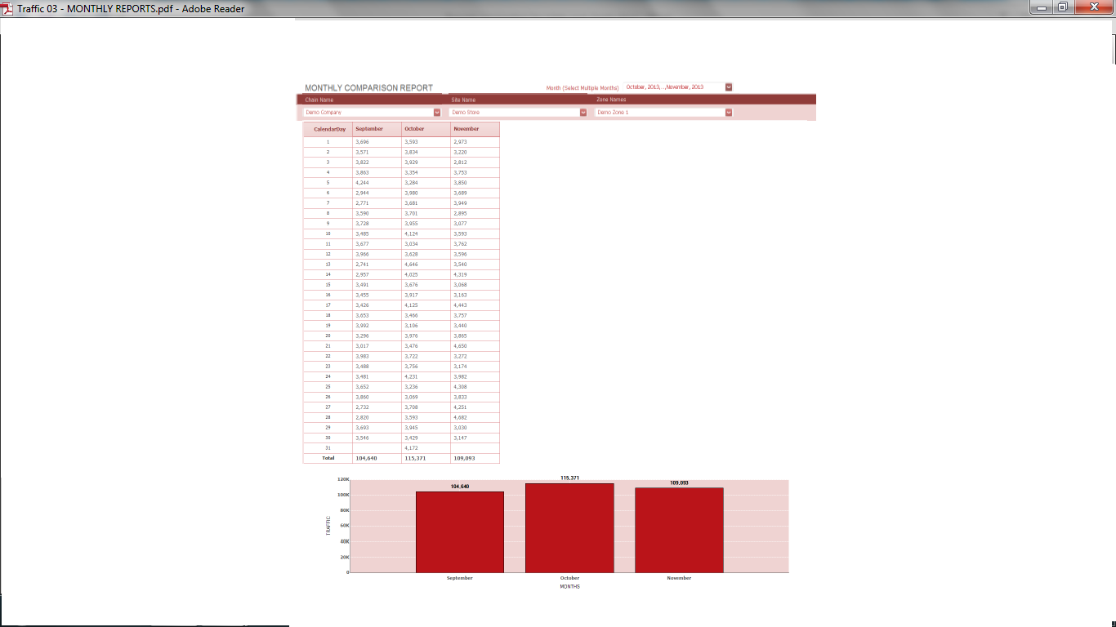

1. **MonthlyRetailExecutiveSummaryReport**

Keep it the same as Hourly Retail Executive Summary report, just name the report as **MonthlyRetailExecutiveSummaryReport** (I will change the values later)

1. **MonthlyRetailTrendAnalysisReport**

Keep it the same as Hourly Retail Trend Analysis report, just name the report as **MonthlyRetailTrendAnalysisReport** (I will change the values later)

* **Monthly Traffic Reports**
  1. **MonthlyTrafficCalendarSummaryReport**

Keep it the same as Hourly Traffic Calendar Summary report, just name the report as **MonthlyTrafficCalendarSummaryReport** (I will change the values later)

* 1. **MonthlyTrafficComparisonReport**

Keep it the same as Hourly Traffic Comparison report, just name the report as **MonthlyTrafficComparisonReport** (I will change the values later)

* 1. **MonthlyTrafficTrendAnalysisReport**

Keep it the same as Hourly TrafficTrend Analysis report, just name the report as **MonthlyTrafficTrendAnalysisReport** (I will change the values later)

* **Yearly Retail Reports**
  1. **YearlyRetailComparisionReport**

Keep it the same as Hourly Retail Comparison report, just name the report as **YearlyRetailComparisonReport** (I will change the values later)

* 1. **YearlyRetailExecutiveSummaryReport**

Keep it the same as Hourly Retail Executive report, just name the report as **YearlyRetailExecutiveSummaryReport** (I will change the values later)

* 1. **YearlyRetailTrendAnalysisReport**

Keep it the same as Hourly Retail Trend Analysis report, just name the report as

**YearlyRetailTrendAnalysisReport** (I will change the values later)

* **Yearly Traffic Reports**
  1. **YearlyTrafficCalendarSummaryReport**

Calendar will get back

* 1. **YearlyTrafficComparisonReport**

Keep it the same as Hourly Traffic Comparison report, just name the report as **YearlyTrafficComparisonReport**(I will change the values later)

**c) YearlyTrafficTrendAnalysisReport**

Keep it the same as Hourly Traffic Trend Analysis report, just name the report as **YearlyTrafficTrendAnalysisReport** (I will change the values later)

**OTHER REPORTS CLIENTS WANT:-**

1. **WeeklyDayWisePerformanceReport**

**Details required in the table:-**

1. MALL ENTRANCES
2. 1-SUN
3. 2-MON
4. 3-TUE
5. 4-WED
6. 5-THU
7. 6-FRI
8. 7-SAT

(this report shows date values based on the date selected(MULTI-SELECT), as shown in this image, can this be done?? SAME AS THE FIRST REPORT WE HAVE SEENX)

**No highchart for this report**

Eg:- This is how this report looks **(pls zoom the picture to see it more clearly)**

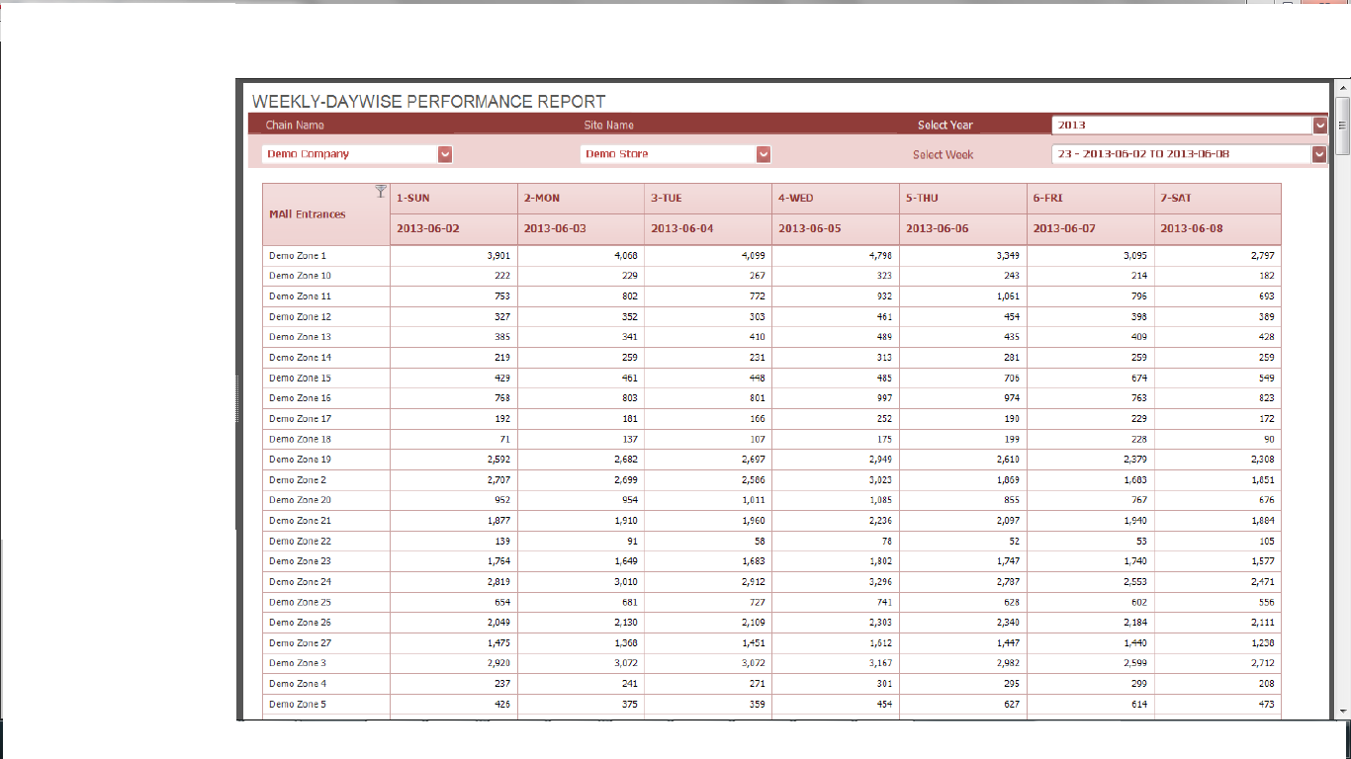

1. **Keyhour Report**

**Details required in the table:-**

1. DAYS
2. Rest of the values are time periods shown

(this report shows something called “THRESHHOLD” (I GUESS, THEY WILL GIVE THE LIMIT FOR WHICH DETAILS ABOVE THAT WILL BE MARKED IN YELLOW COLOR, SO THE VALUES SPECIFIED INSIDE THIS (13), VALUES ABOVE 13 WILL BE MARKED IN YELLOW..

**No highchart for this report**

Eg:- This is how this report looks**(pls zoom the picture to see it more clearly)**

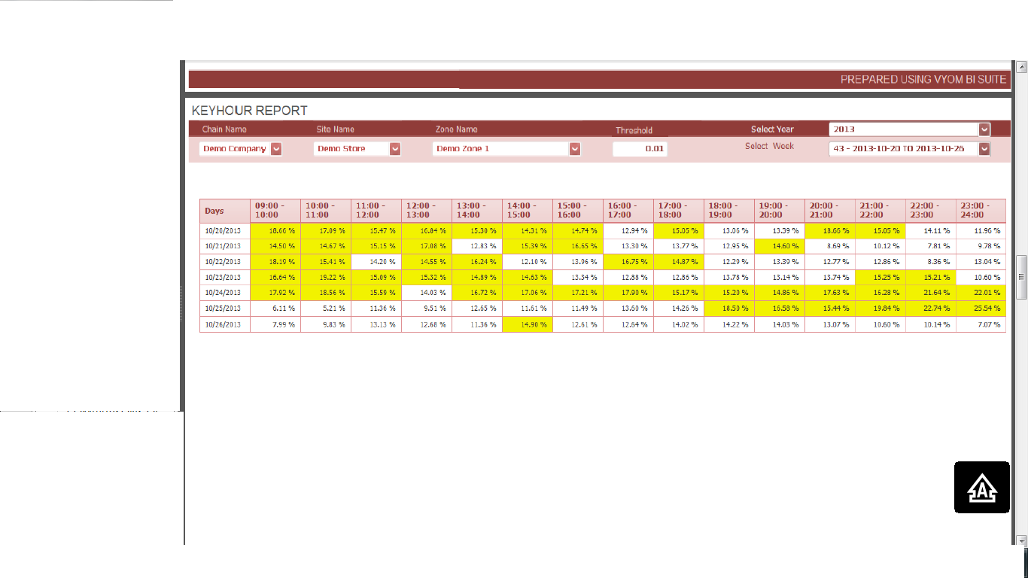

1. **Weekly hourly Report**

THIS REPORT IS GOING TO BE ACHIEVED FROM THE ABOVE REPORTS ITSELF, BUT SHOWING YOU A REPORT HOW A CLIENT MAY ASK

**(pls zoom the picture to see it more clearly)**

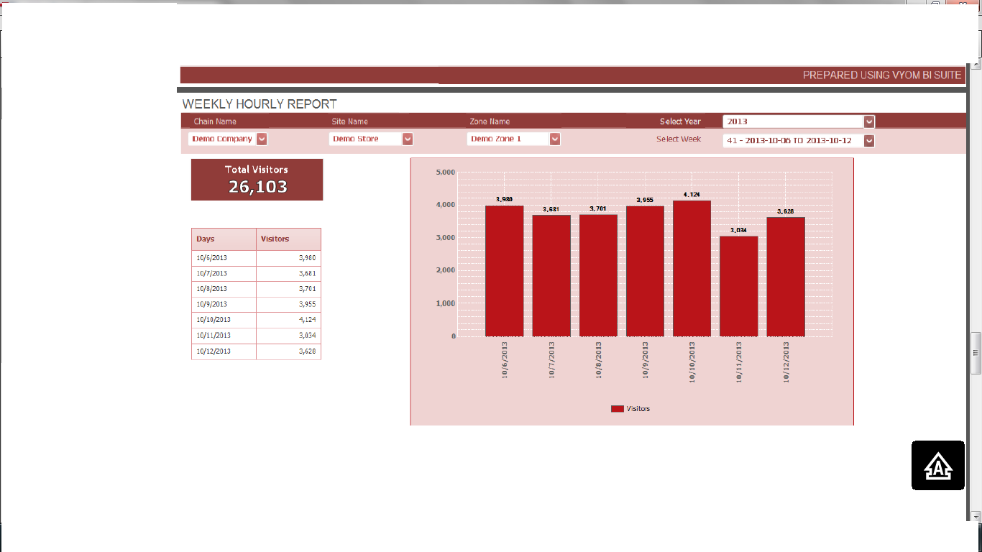

1. **Weekly Comparison Report(different from the one above)**

No table, only the div values of total visitors and the highchart, with colors beside the chart showing what color is indicating which value inside the chart

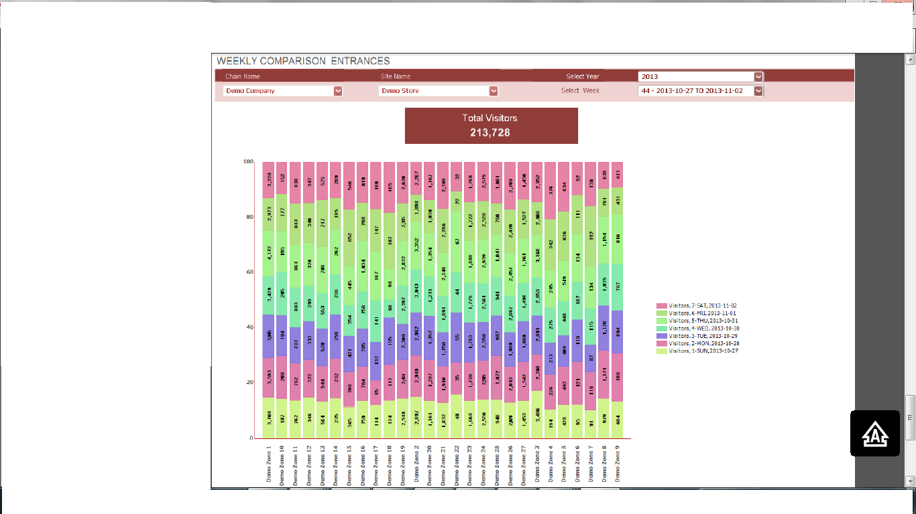

1. **Hourly Comparison Sites (different from the one above)**

**Table requirements:-**

1. Time period
2. Visitors from a particular site

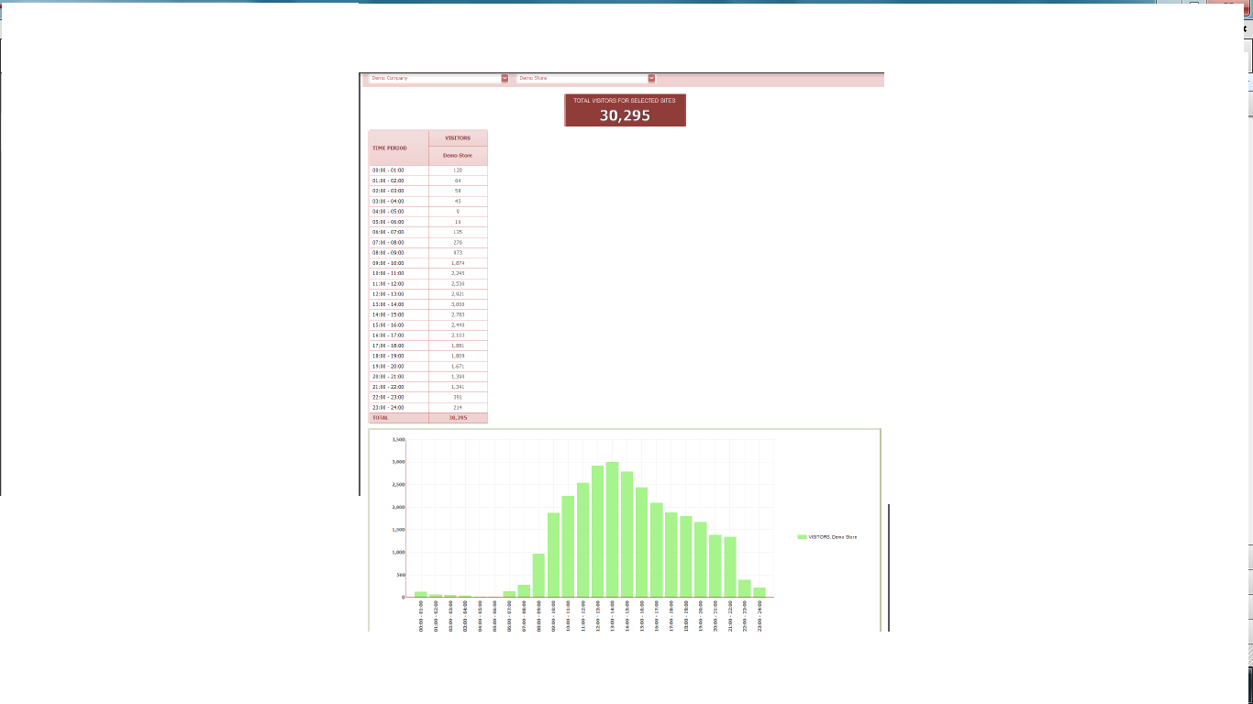

1. **Monthly Performance Report (different from the one above)**

**Table requirements:-**

1. Days
2. Visitors
3. %Visitors (Its shows a bar chart)
4. PastMonth
5. %Change% (negative rows are shown in pink and positive rows in green)
6. PastYear
7. %Change

**Details required in high charts:-**

Visitors (This highchart has to come down)**(pls zoom the picture to see it more clearly)**

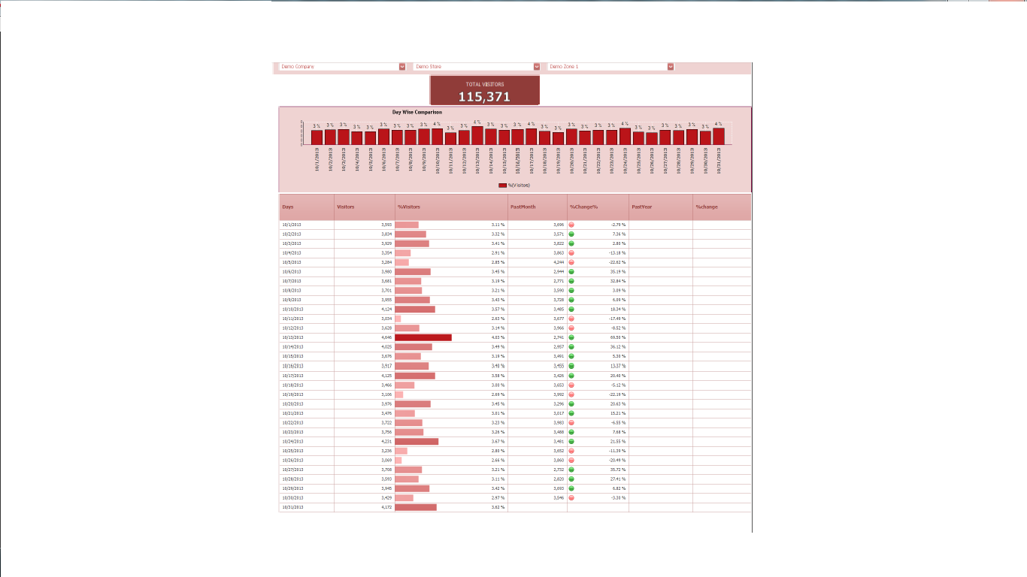

1. **Monthly KeyHour Report (different from the one above)**

**Table requirements:-**

1. Days
2. Time Periods

Pls note:-(this report shows something called “THRESHHOLD” (I GUESS, THEY WILL GIVE THE LIMIT FOR WHICH DETAILS ABOVE THAT WILL BE MARKED IN YELLOW COLOR, SO THE VALUES SPECIFIED INSIDE THIS (13), VALUES ABOVE 13 WILL BE MARKED IN YELLOW..

**No Highchart Required:-**

